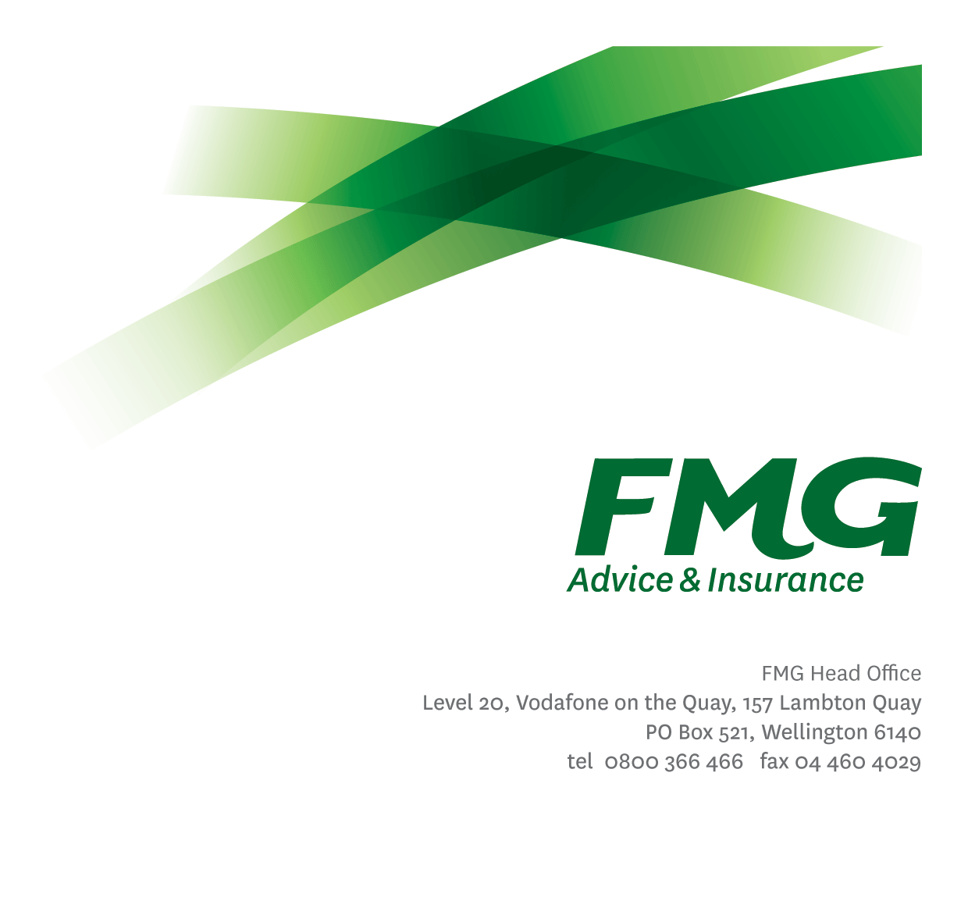
Senior Pricing and Portfolio Analyst

Position Description

Location: Wellington

Reporting to: Pricing & Portfolio Analytics Team Manager

Business Unit: Insurance Solutions

Direct Reports: Nil

Date Last Reviewed: April 2026

About FMG
Formed by farmers for farmers over a century ago, FMG is New Zealand’s leading rural insurer providing risk advice and insurance solutions for farmers, growers, commercial businesses, the lifestyle sector and residential clients.
FMG is proudly 100% New Zealand owned and operated, and our focus is on helping our clients to achieve their goals. As a mutual organisation, FMG is all about giving rural New Zealanders a better deal, and part of this involves reinvesting all profits back into the business to keep premiums low and ensure the future sustainability of the Mutual.

FMG’s Values
FMG’s brand represents promises about what clients can expect from the Mutual and each FMG employee across our One Team is responsible for delivering on these promises. Living FMG’s Values means we all deliver the best brand experience for our clients. FMG’s Values are:
- Do what's right - Whāia te ara tika | - Make it happen - Whakatutukitia
- We're in it together - Ko tātau tātau | - Proud of who we are - Whakahīhī i te whakapapa

Work Environment
FMG strives to provide an environment that promotes and fosters achievement, placing importance on career development and training to provide our people with the tools they need to succeed.
FMG’s Head Office is located in Wellington and accommodates FMG’s Executive Leadership Team (ELT), Sales, Advice and Service, Claims, Marketing and Propositions, People and Culture, Finance and Investments, Insurance Solutions, Digital and Data, Risk and Compliance and Strategy and Enablement teams.
FMG’s largest regional office is in located in Palmerston North accommodating FMG’s National Sales and Advice Centre, People and Culture, Digital and Data, Claims, Operations and Payments functions. In addition to offices in Wellington, Palmerston North and Christchurch, FMG has regional offices in 30 locations throughout provincial New Zealand Aotearoa.

Purpose of the role
To provide technical and analytical insight that contributes to improving the pricing and performance of FMG’s portfolios and products.

Key Responsibilities
Area | Responsibilities
Pricing and Portfolio Strategy | - Contribute to strategic Pricing and Portfolio decisions at FMG.  - Assist the Pricing and Portfolio Analytics Team Leader with the delivery of FMG’s pricing strategies – ensuring compliance with relevant levies and FMG specific requirements.  - Design and development of pricing models and processes.
Technical Analysis | - Develop, implement, and maintain technical pricing models, design and produce reporting to monitor and assess portfolio level trends.  - Monitor performance and trends within and across product portfolios, including competitor monitoring, variances in performance against targets, pricing and excess changes.  - Identifies and recommends opportunities to improve FMG’s pricing and best practise, including presenting recommendations to senior leaders.  - Design and define process requirements for new and existing processes.  - Assist other FMG business units with pricing related queries.
Collaboration and Teamwork | - Lead medium initiatives on behalf of Pricing & Portfolio Analytics Team Leader.  - Help develop the technical capabilities within the Pricing and Portfolio Analytics team by mentoring other team members and helping with specific technical queries and tasks.  - Assists and supports stakeholders and colleagues from other teams.  - Undertakes tasks as directed by the Pricing and Portfolio Analytics Team Leader from time to time.  - Completes work to agreed deadlines.
Self-Development | - Actively identifies areas for development and attends company approved training and development programs as required.
Compliance | - Ensures regulatory compliance.  - Support of client remediation activities as required.
Wellbeing & Safety | - Complies with safety and wellbeing policy and procedures, including accident and incident reporting and hazard management requirements.  - Works in a safe manner at all times and does not undertake activities without appropriate training.

 | COMPETENCIES
 | *see competency framework for behaviours expected at each level |  |  | Expected Level
 | Client Driven (Internal & External)  A commitment to understanding the needs and best interests of both internal and external clients, in order to provide them with outstanding customer service and help them to make informed decisions. |  |  | Intermediate*
 | Accountability  Taking personal ownership of decisions, behaviour, and development, and being responsible for how these actions impact on the wider organisation and clients. |  |  | Advanced*
 | Adaptability  Demonstrating a willingness to engage in a changing environment and being flexible and comfortable working with change. |  |  | Intermediate*
 | Motivation and Drive  The determination to achieve goals and strive for excellence. |  |  | Intermediate*
 | Relationship Building  Developing and maintaining positive, professional relationships that are built on mutual trust and respect. |  |  | Intermediate*
 | Teamwork  Making a positive contribution to FMG and collaborating effectively with others to achieve objectives. Mentoring within the Pricing and Portfolio Analytics team. |  |  | Advanced*
 | Strategic Thinking  The capacity to stand apart from the day-to-day and take a long-term, big picture view of the business. |  |  | Intermediate*
 | Critical Analysis  The capability to identify key issues, trends, or important facts from information and to question and probe. |  |  | Advanced*
 | KNOWLEDGE
 | Qualifications |  | Relevant tertiary qualification in fields such as mathematics or statistics.
Experience |  | 5 years insurance industry experience in an analytical role, preferably General Insurance pricing.  Demonstrated experience with data manipulation, cost modelling and forecasting.
 | Business Awareness |  | Understands the internal workings of FMG and how business works; understands FMG's position in the advice and insurance market and knows the competition.
 | Product Knowledge |  | Is knowledgeable about FMG's insurance policies and packages, the differences between them, and the appropriateness of each in different situations.
 | Risk/Insurance Knowledge |  | Understands risk and how to apply FMG's policies to situations; is knowledgeable about compliance requirements.
 | Specialist Knowledge |  | Understands the core principles of insurance pricing.  Understands the roles of Underwriting, Sales, Claims etc and can use their viewpoint in analysing product performance.

SKILLS
Written Communication Skills | Able to write clear, concise and persuasive proposals and reports.
Verbal Communication Skills | Communicates clearly in order to present information to persuade and influence others.
Technology Skills | Can expertly use relevant software and technology to its full capacity e.g. SAS, Excel, MS Word, PowerPoint.
Listening Skills | Demonstrates active listening skills through eye contact, paraphrasing, appropriate body language and checking understanding.

Key Relationships
External | Internal | Committee/Groups
- Underwriting
- Product
- Claims
- Sales, Advice & Service
- Reinsurance
- Actuarial
- Marketing and Propositions
- Digital and Data

Financial Authority Levels
- No authority to approve or commit expenditure

People Advisory Authority Levels
- Not applicable

Agreement

I agree to the outline of the role as contained in this document and recognise that the contents may need to be amended from time to time to reflect changing business requirements.

I as Job holder, allow my Manager to gather information from third parties where necessary for the purposes of performance management.

Name:
Signature:
Date:

