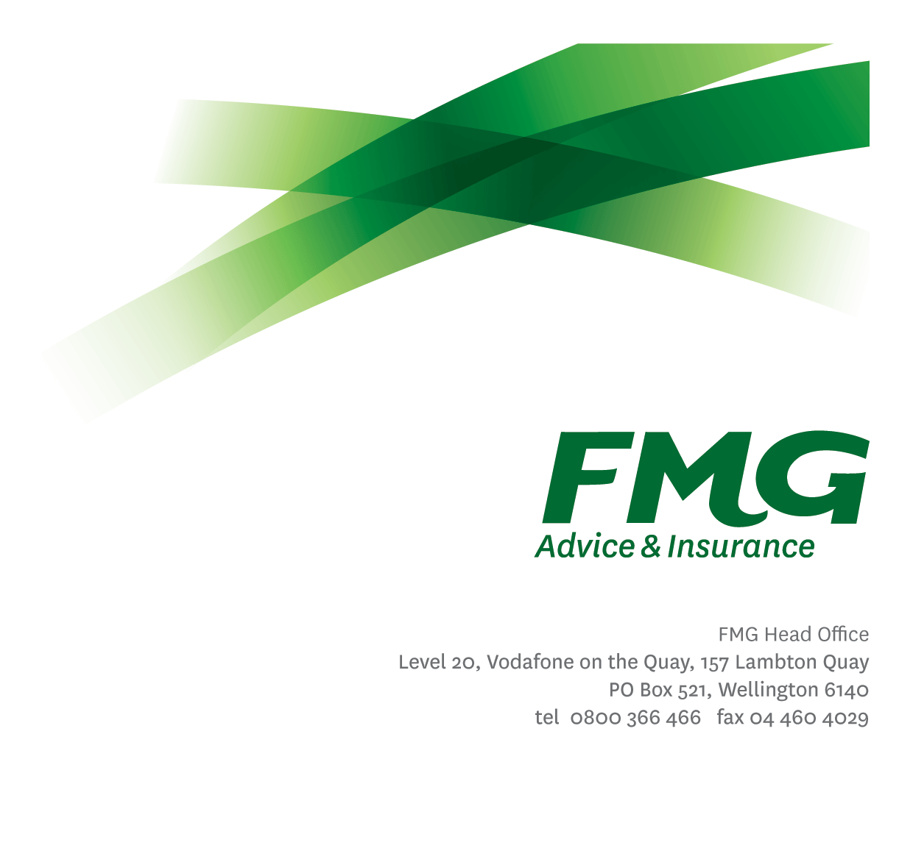
Senior Quality Assurance Analyst
Position Description

Location: Palmerston North or Wellington
Reporting to: Delivery Manager
Business Unit: Digital and Data
Direct Reports: N/A
Date Last Reviewed: February 2026
About FMG
Formed by farmers for farmers over a century ago, FMG is New Zealand’s leading rural insurer providing risk advice and insurance solutions for farmers, growers, commercial businesses, the lifestyle sector and residential clients.
FMG is proudly 100% New Zealand owned and operated, and our focus is on helping our clients to achieve their goals. As a mutual organisation, FMG is all about giving rural New Zealanders a better deal, and part of this involves reinvesting all profits back into the business to keep premiums low and ensure the future sustainability of the Mutual.
FMG’s Values
FMG’s brand represents promises about what clients can expect from the Mutual and each FMG employee across our One Team is responsible for delivering on these promises. Living FMG’s Values means we all deliver the best brand experience for our clients. FMG’s Values are:
- Do what's right - Whāia te ara tika | - Make it happen - Whakatutukitia
- We're in it together - Ko tātau tātau | - Proud of who we are - Whakahīhī i te whakapapa
Work Environment
FMG strives to provide an environment that promotes and fosters achievement, placing importance on career development and training to provide our people with the tools they need to succeed.
FMG’s Head Office is located in Wellington and accommodates FMG’s Executive Leadership Team (ELT), Sales, Advice and Service, Claims, Marketing and Propositions, People and Culture, Finance and Investments, Insurance Solutions, Digital and Data, Risk and Compliance and Strategy and Enablement teams.
FMG’s largest regional office is in located in Palmerston North accommodating FMG’s National Sales and Advice Centre, People and Culture, Digital and Data, Claims, Operations and Payments functions. In addition to offices in Wellington, Palmerston North and Christchurch, FMG has regional offices in 30 locations throughout provincial New Zealand Aotearoa.

Purpose of the role
Senior Quality Assurance (QA) Analyst works in a cross-functional product delivery team, collaborating with key internal and external stakeholders to ensure that software applications meet both specified and emerging requirements and deliver high-quality outcomes. This role leads and actively participates in the planning, creation, and execution of comprehensive test strategies, including risk-based and exploratory testing, while also preventing, identifying, and tracking defects. In addition to hands-on testing, the Senior QA Analyst mentors team members, drives continuous improvement of Quality Assurance practices within the team, and proactively influences requirements, design, and delivery decisions to support the successful delivery of robust, reliable products.

Key Responsibilities

Area |  | Responsibilities
 | FMG Company Values |  | - To promote the “FMG Way” through displaying the values of FMG which are do what’s right, make it happen, we’re in it together and proud of who we are
 | Leadership |  | - Fulfils QA Lead role  - Develops and promotes QA standards and processes, ensuring they are well understood and consistently applied across teams.  - Mentors and supports QA team members, building capability in test design, execution, and modern QA practices.  - Defines test approaches for complex features and cross-team initiatives, with a strong focus on risk-based testing.  - Drives continuous improvement, contributing to quality initiatives and helping evolve tools, frameworks, and practices.  - Leads stakeholder engagement, ensuring quality requirements are clearly defined, communicated, and met
Testing |  |  | - Selects and applies appropriate testing methods, techniques, approaches, with a strong emphasis on automation where applicable.  - Designs and executes tests across all development stages, including risk-based and exploratory testing.  - Collaborates with cross-functional teams to define acceptance criteria, ensure testability, and embed quality early.  - Executes testing across all levels, prevents, investigates and reports defects, and works closely with developers for quick resolution.  - Contributes to the creation and execution of automated test cases, demonstrating a willingness to learn scripting and automation tools.  - Executes log validation and monitoring checks during test execution, and analyses log outputs to identify errors, performance issues, and unexpected behaviours.  - Supports non-functional testing (e.g., performance, security, accessibility) and contributes to continuous improvement of QA standards.  - Designs, facilitates, and leads BAT and UAT activities with business stakeholders  - Provides clear reporting on testing outcomes.
Definition and Application of Technical Standards |  |  | - Leads the development and continuous improvement of QA standards, frameworks, and best practices, to support delivery, ensuring alignment with architecture and infrastructure.  - Promotes a culture of quality, actively contributing to FMG’s QA Practice.
Systems Architecture & Application Infrastructure |  |  | - Maintains an awareness of and advocates for the FMG systems architecture and associated guidelines
Personal Development |  |  | - Maintains an up-to-date personal development plan aligned with role expectations and career aspirations.  - Engages in ongoing learning through training, certifications, and knowledge-sharing within the team.  - Uses regular feedback and performance reviews to identify growth opportunities and support continuous improvement
Other Duties |  |  | - Undertakes additional tasks as directed by management from time to time  - Provide flexible support to delivery outcomes, recognising occasional work outside standard hours.
Health & Safety |  |  | - Complies with safety and wellbeing policy and procedures, including accident and incident reporting and hazard management requirements  - Works in a safe manner at all times and does not undertake activities without appropriate training
COMPETENCIES
*see competency framework for behaviours expected at each level |  |  |  | Expected Level
Customer Driven (Internal & External)  A commitment to understanding the needs and best interests of both internal and external customers, in order to provide them with outstanding customer service and help them to make informed decisions. |  |  |  | Advanced*
Accountability  Taking personal ownership of decisions, behaviour, and development, and being responsible for how these actions impact on the wider organisation and customers. |  |  |  | Advanced*
Adaptability  Demonstrating a willingness to engage in a changing environment and being flexible and comfortable working with change. |  |  |  | Intermediate*
Motivation and Drive  The determination to achieve goals and strive for excellence. |  |  |  | Intermediate*
Relationship Building  Developing and maintaining positive, professional relationships that are built on mutual trust and respect. |  |  |  | Intermediate*
Team Work  Making a positive contribution to the FMG team and collaborating effectively with others to achieve objectives. |  |  |  | Advanced*
Critical Analysis  The capability to identify key issues, trends, or important facts from information and to question and probe. |  |  |  | Advanced*
Problem Solving  The ability to understand information from a variety of sources and think quickly on one’s feet. The ability to effectively combine verbal and numeric data into a coherent whole. |  |  |  | Advanced*

KNOWLEDGE
Qualifications | Bachelor’s degree in Computer Science, Software Engineering, or other relevant tertiary qualification is preferred, or equivalent experience. Relevant certifications such as ISTQB are advantageous.
Business Awareness | Understands the internal workings of FMG and how business works; understands FMG's position in the advice and insurance market and knows the competition.
Systems Knowledge | Proficient knowledge of FMG’s core systems and integration points
Specialist Knowledge | Extensive experience in software Quality Assurance with a focus on Quality Engineering.  Understanding of software development life cycle (SDLC) and Agile methodologies, and FMG IT Architecture.  Familiar with AI-powered testing tools.

SKILLS
Written Communication Skills | Able to write clear, concise and persuasive proposals and reports.
Verbal Communications Skills | Communicates clearly to present information to persuade and influence others
Listening Skills | Demonstrates active listening skills.
Soft Skills | Communicates clearly within the team and across teams, adapts messaging for different audiences, and proactively navigates stakeholder environments.
Technology Skills | Understands modern Quality Assurance methodology, techniques, and tools.  Demonstrates understanding of Quality Engineering practice.  Understands Test Automation frameworks and Test Tools
Analytical Skills | Data-driven decision making  Metrics analysis and trend identification  Root cause analysis  Risk assessment

Relationship
External | Internal | Committees/Groups
- System Providers  - External partners | - FMG Delivery Team  - FMG Employees  - System users | - Big Room Planning  - Communities of Practice

Financial Authority Levels
- No authority to approve or commit expenditure

Human Resources Authority Levels
- No authority to dismiss staff, unless delegated by the Chief Executive and in consultation with manager and Human Resources.

Agreement
Agreement
I agree to the outline of the role as contained in this document and recognise that the contents may need to be amended from time to time to reflect changing business requirements.

I as Job holder, allow my manager to gather information from third parties where necessary for the purposes of performance management.

Agreement will be via electronic signature as evidenced on the acceptance form.

